**Practical No 16 and 17: Write queries using inner and outer joins.**

1. **Joins in SQL:**
2. **INNER JOIN:**

The INNER JOIN keyword selects records that have matching values in both tables.

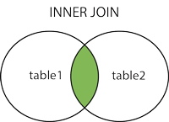

1. **OUTER JOIN:**

The SQL OUTER JOIN returns all rows from both the participating tables which satisfy the join condition along with rows which do not satisfy the join condition. The SQL OUTER JOIN operator (+) is used only on one side of the join condition only.

1. **LEFT (OUTER) JOIN:**

The LEFT JOIN keyword returns all records from the left table (table1), and the matching records from the right table (table2). The result is 0 records from the right side, if there is no match.

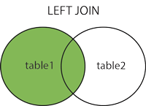

1. **RIGHT (OUTER) JOIN:**

The RIGHT JOIN keyword returns all records from the right table (table2), and the matching records from the left table (table1). The result is 0 records from the left side, if there is no match.

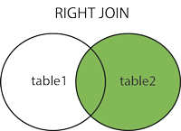

1. **FULL (OUTER) JOIN:**

The FULL OUTER JOIN keyword returns all records when there is a match in left (table1) or right (table2) table records.

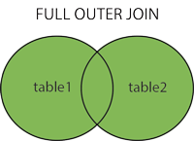

1. **Practical Related Questions:**
2. **Define the terms EQUI JOIN, NONEQUI JOIN.**

An equi join is any JOIN operation that uses an equal’s sign and only an equal’s sign. You will see queries that use more than one join condition; if one condition is an equals sign and the other isn't, that's a considered a non equi join in SQL.

1. **Differentiate between LEFT JOIN and RIGHT JOIN.**

The main difference between these joins is the inclusion of non-matched rows. The LEFT JOIN includes all records from the left side and matched rows from the right table, whereas RIGHT JOIN returns all rows from the right side and unmatched rows from the left table.

1. **State the difference between JOIN and UNION.**

UNION in SQL is used to combine the result-set of two or more SELECT statements. The data combined using UNION statement is into results into new distinct rows. JOIN combines data from many tables based on a matched condition between them. It combines data into new columns.

1. **State the need for SELF JOIN.**

A self-join allows you to join a table to itself. It is useful for querying hierarchical data or comparing rows within the same table. Because the query that uses self-join references the same table, the table alias is used to assign different names to the same table within the query.